* **Contact:** +91 7533859871
* **Address:** Auraiya, Uttar Pradesh, India
* **Github:** github.com/siddharthSharma102
* **Portfolio:** https://siddharthsharma.netlify.app
* **Linkedin:** linkedin.com/in/Siddharth-sharma102

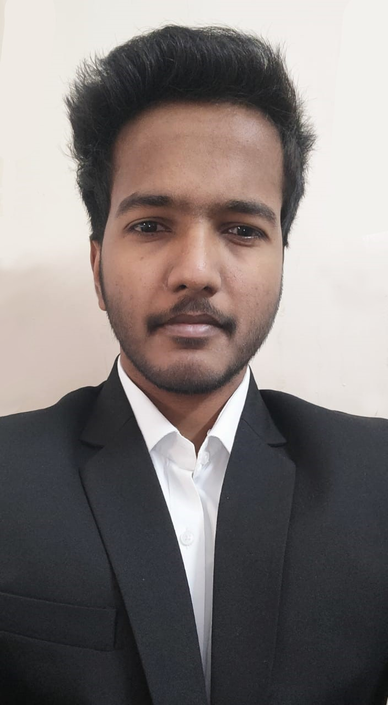

**Siddharth Sharma**

Actively Seeking Opportunities |

2022 Graduation

**Experience**-----------------------------------------------------------------------------------------------------------------------------------------------

* *Sept 2020 – Mar 2021* ***London Strategy & Consulting Group (LSCG)*** **|** **Software Development Intern**
* Worked with *software development team* and was given the opportunity to work on multiple projects. Also I supported other teams with **problem solving** and **troubleshooting**.
* Responsibilities undertaken:
  + Development of **application** **server** for the project. I was responsible for designing the **front-end** of the web-application, and management of the **REST** **API’s***.*
  + Development of **android app UI** and wireframe for each screen of the app.

*Tech used: Python, Flask, Flutter, Dart, Web-Development, Android Development.*

* *July 2020 – Aug 2020* ***GAIL (India) Limited* | Vocational Trainee**
* Worked with the network department and worked on the development of **Movable Asset Management System (MAMS).** Responsibilities Undertaken:
  + I was responsible for the development of **application server** and designing of the web-app **UI.**

*Tech used: Python, Flask, Web-Development.*

* *May 2020 – June 2020* **Benett University | AI Trainee**
* Collaborated with a team of 5 members and developed **Fake News Detection System**. Multiple **Kaggle datasets** were used for this project.
* Responsibilities undertaken:
  + Developed multiple **neural network models** for the project’s models (architecture used – *CNN, Deep-CNN, Multi-Channel CNN, LSTM*).

*Tech used: Python, Tensorflow, Artificial Intelligence*

**Education**-------------------------------------------------------------------------------------------------------------------------------------------------

* *Aug 2018 – July 2022* **Bachelors Of Technology** (B.Tech.) - **(CGPA: 8.2/10)**

**PSIT College Of Engineering** (Dr. APJ Abdul Kalam Technical University) (Present – 4th Year)

* *June 2017 – May 2018* **Intermediate** (Class 12th) - **(Percentage: 88.6%)**

**GAIL DAV Public School** (C.B.S.E)

* *June 2015 – May 2016* **High School** (Class 10th) - **(Percentage: 91.2%)**

**GAIL DAV Public School** (C.B.S.E)

**Technical Proficiencies**---------------------------------------------------------------------------------------------------------------------------

* **Languages:** Python, C
* **DB Language:** MongoDB, SQL
* **Frameworks:** Tensorflow, Scikit-Learn, Streamlit, Flutter
* **IT Components:** Data Structures & Algorithms, OOPS, OS & DBMS
* **Development Tools:** Visual Studio Code, PyCharm, Android Studio, Jupyter, Spyder
* **Skills :** Artificial Intelligence, Web-Development

**Projects**----------------------------------------------------------------------------------------------------------------------------------------------------

* **Gesture Cursor Control (Ongoing) –**The project is based on **Gesture Recognition** using AI, which involves neural network models for detection of gestures. Responsibilities Undertaken –
  + Developed Neural Network models for the project.
  + Contributed in creation of dataset for dataset for model training purpose.

***Skills & Languages*** *– Tensorflow, Pandas, Python, OpenCV, Pynput.*

* **ELIFCODE (Ongoing) –** **It** is a platform which aims to improve its users coding efficiency by making them solve gamified programming problems with other users in real-time. They can also participate in regular contests as well. Users can also share their solutions at the end of a contest to help others improve. A team of 5 members are currently working on this. Responsibilities Undertaken-
  + Developed code for Flask server.
  + Designed and developed frontend for the same.
  + Developed code runner (it will provide the output of the code submitted by the users).

***Skills & Languages*** *– Python, Flask, HTML, CSS.*

* **Emotion Detection System –** The project is an application of **Artificial Intelligence** which utilizes the ***Computer Vision*** concepts for the detection and recognition of emotions by the *human facial emotions* using real-time image/video inputs. Responsibilities undertaken –
  + Developed **neural network** based models for the objective, designed and developed the web-app **frontend** for the project.

***Skills & Languages*** *– Python, Tensorflow, Streamlit, Artificial Intelligence.*

* **Hoax Classifier –** The project is an application of ***Artificial Intelligence*** which utilizes the ***NLP (Natural Language Processing)*** concepts for the detection ***Fake News.*** There were multiple ***kaggle*** datasets used throughout the process for the development of the ***neural network models***. Responsibilities undertaken –
  + Developed multiple neural network based models for the objective, i.e. CNN, Multi-Channel CNN, LSTM.

***Skills & Languages*** *– Python, Tensorflow, Pandas, Artificial Intelligence.*

**Achievements**------------------------------------------------------------------------------------------------------------------------------------------

* **Hackerrank** ***5 star*** Python coder & ***4 star*** C coder.
* Secured ***1st position*** at **Sports Tournament** in football organized by KIT, Kanpur.
* Secured ***2nd******position*** at **District Tournament** in mime act organized by AKTU, Lucknow.
* Selected for **National Sports tournament** in football.
* **Certifications :**
  + **Microsoft** Technical Associate (MTA),
  + **NVIDIA** DLI Certificate Of Competency
  + Improving Deep Neural Networks by **DeepLearning.ai**

**Declaration**---------------------------------------------------------------------------------------------------------------------------------------------- I hereby declare that all the information mentioned above is true to the best of my knowledge.

Date: 23-08-2021

Place: Kanpur **(Siddharth Sharma)**